Procurement Automation Configuration - Deliverable
MGIS 4580 – Fall 2024 – Project 1
Insert screenshots into the sections below, as requested in the instructions file.

Automate PO Creation from PRs

Step 6: Run the Automatic Creation of Purchase Orders (ME59N)
Paste your ME59N screenshot below.
Forgot to take the screenshot

Step 7: Display Your Automatically Generated Purchase Order
Paste your purchase order screenshots below.
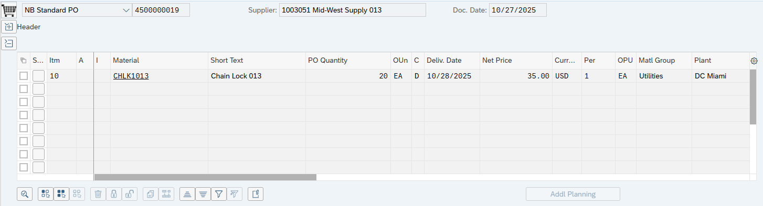
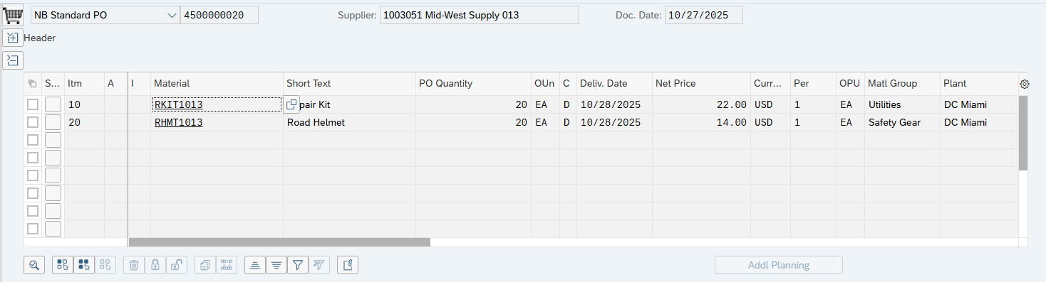
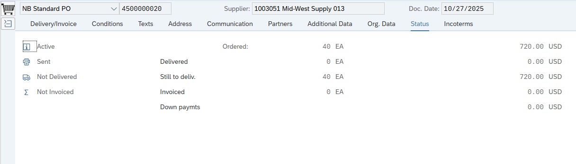
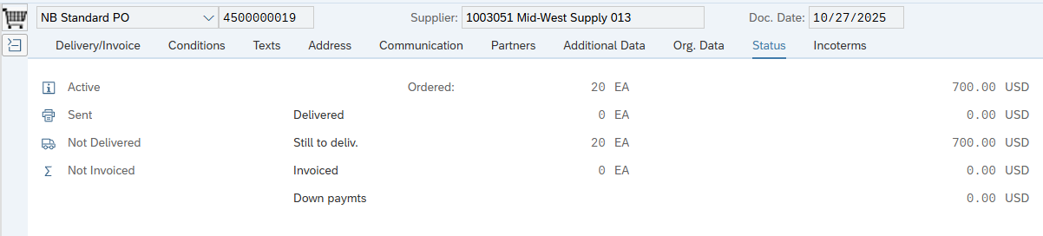

Step 9: Display Your Automated PO
Paste your goods receipt screenshot below.
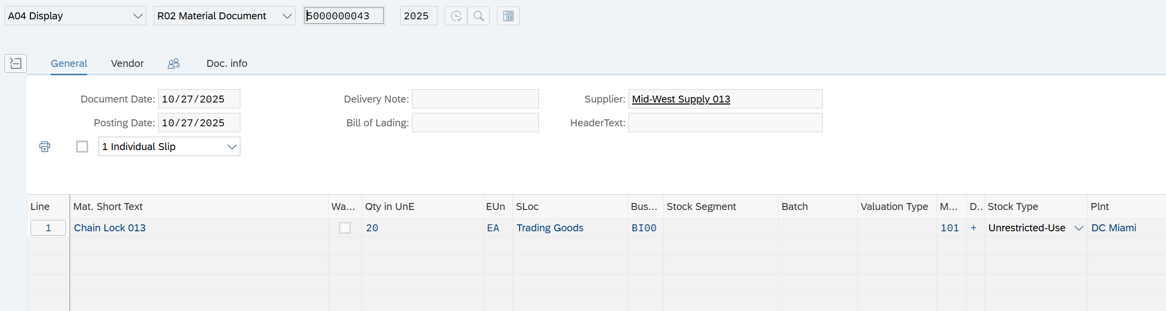
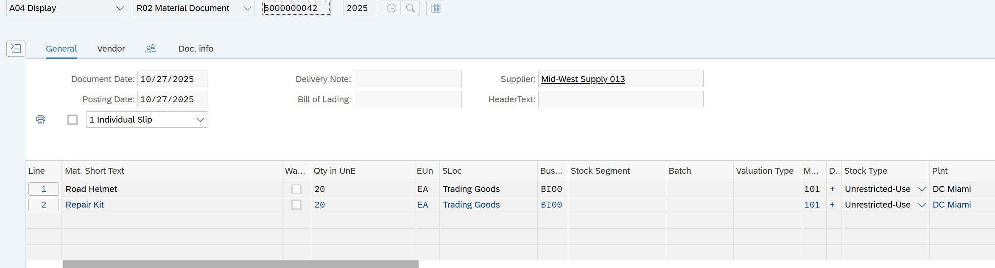

Step 10: Record the Vendor Invoice
Paste your payment document details screenshot below.
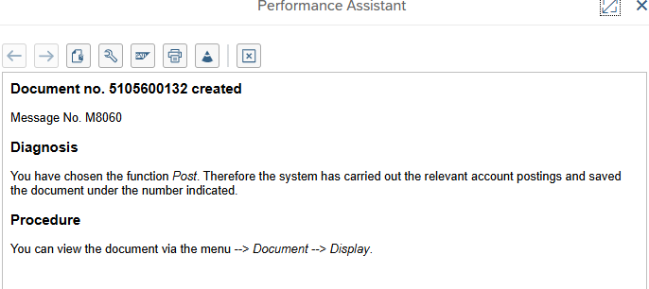
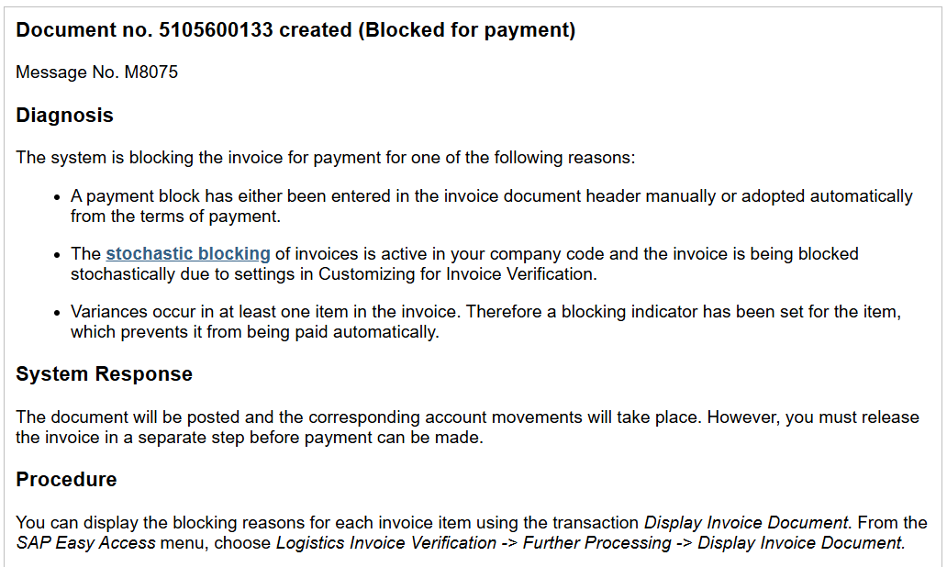

Step 12: View Vendor Balance
Paste your vendor balance results below.
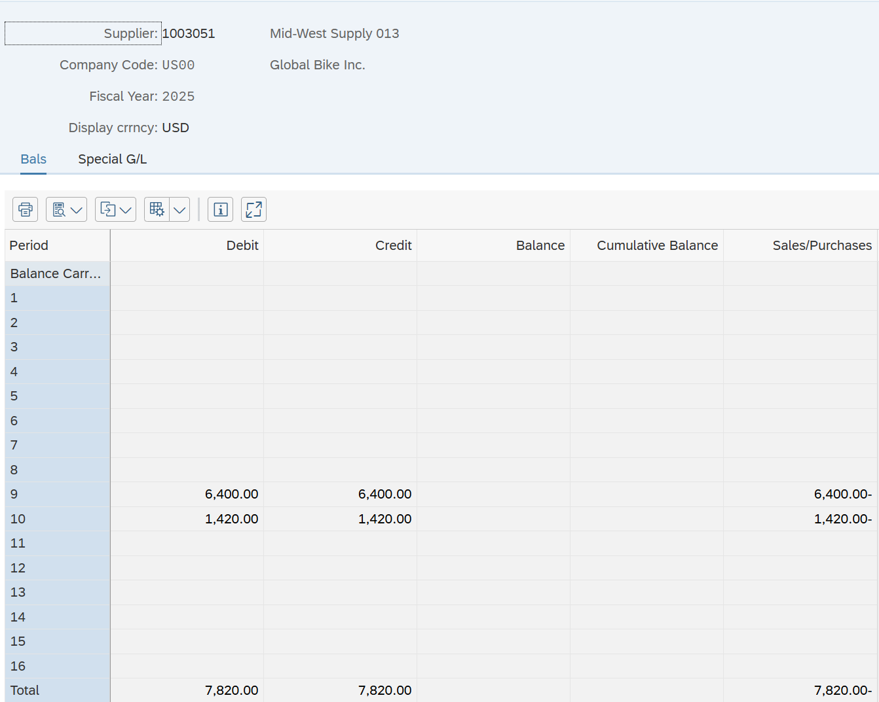

Evaluated Receipt Settlement - ERS (T-Code: MRRL)

Step 4: Create Purchase Requisition
Paste your purchase requisition number below.
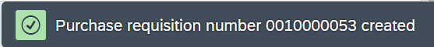

Step 5: Run the Automatic Creation of Purchase Orders (ME59N)
Paste your ME59N screenshot below.
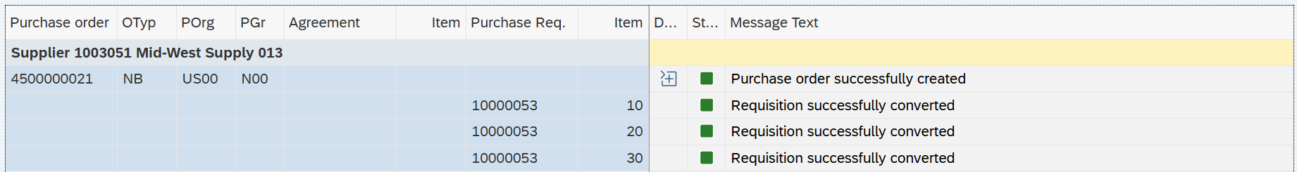

Step 6: Display the ERS Setting on the PO
Paste your PO item details screenshot below.
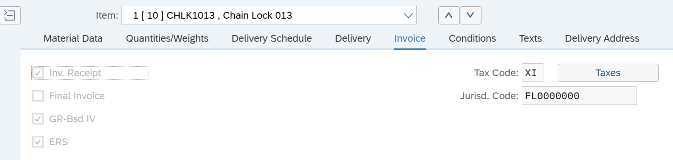
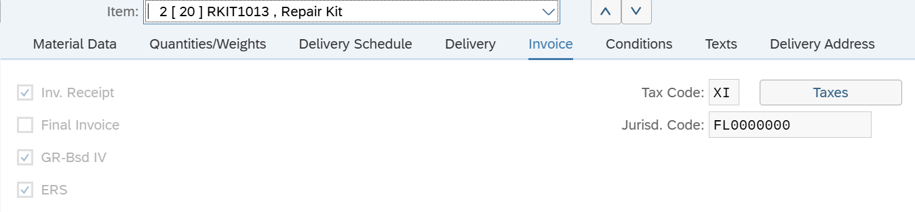
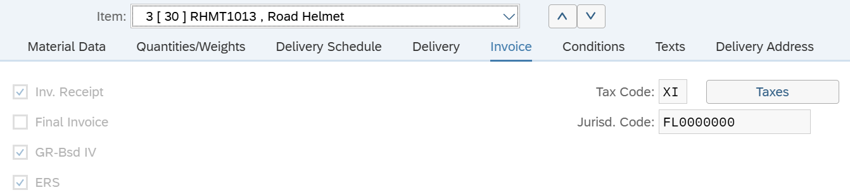

Step 7: Receive Goods from Your PO
Paste your goods receipt number below.
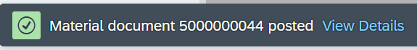

Step 8: Run Evaluated Receipt Settlement (MRRL)
Paste your MRRL screenshot below.

Step 9: View Vendor Invoices
Paste your vendor invoices screenshot below.

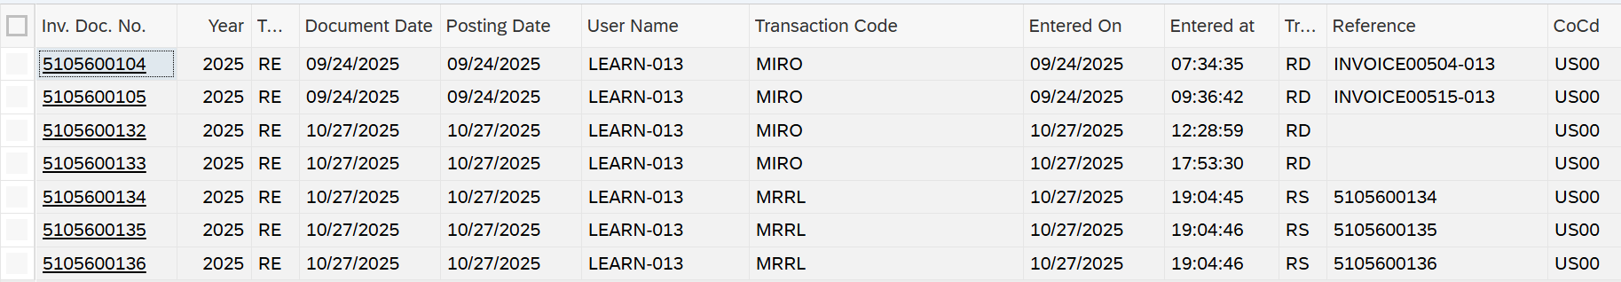

Step 10: Post Payment to the Vendor
Paste your vendor’s open items screenshot below.
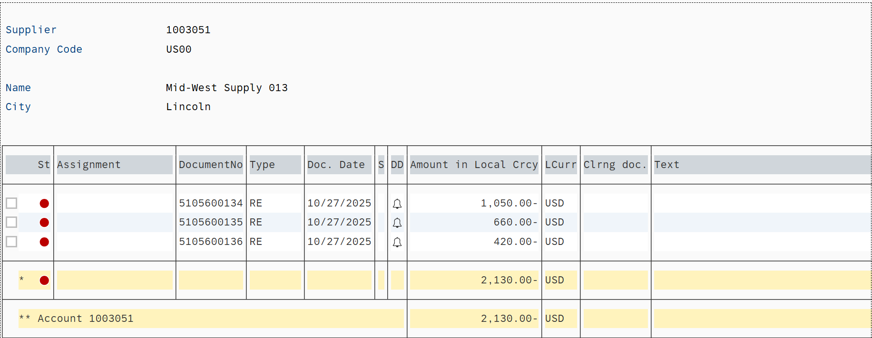
Paste your payment document number below.

Step 11: View Vendor Balance
Paste your vendor balance screenshot below.
